Dock piling inspection April 2019
As you can see from the pictures we are having issues with the dock brackets digging into the pilings. These pilings are only a couple of years old. Some of these issues are because the new pilings don’t line up with the brackets on docks.
Other issues are just wear and the remedy would be to install “slippery” deck boards such as Trex so the nylon spacer on the docks slides up against the deck board mounted on the piling. The deck boards have enough plastic in them to make them glide on the nylon.
We have used the decks boards on the pilings before and it greatly reduces wear to almost nothing. Most of the pilings have been replaced but we haven’t added the deck boards to them. I would recommend installing the deck boards on all pilings and we may also need to move the brackets so they align with the docks better.
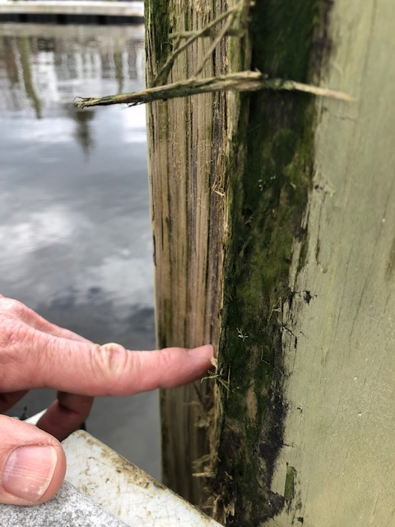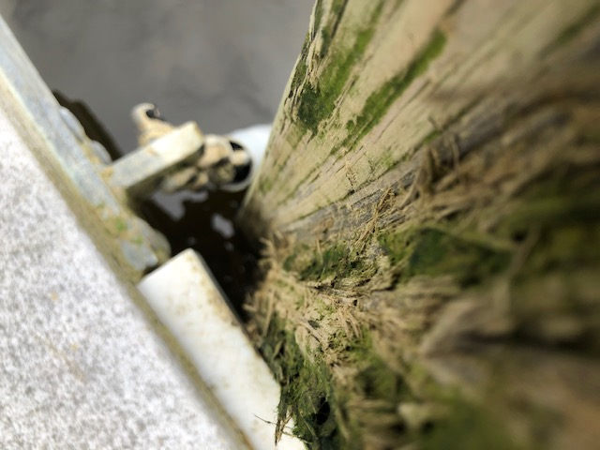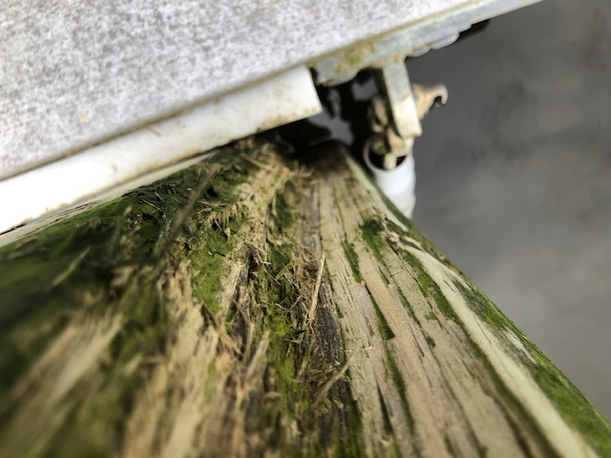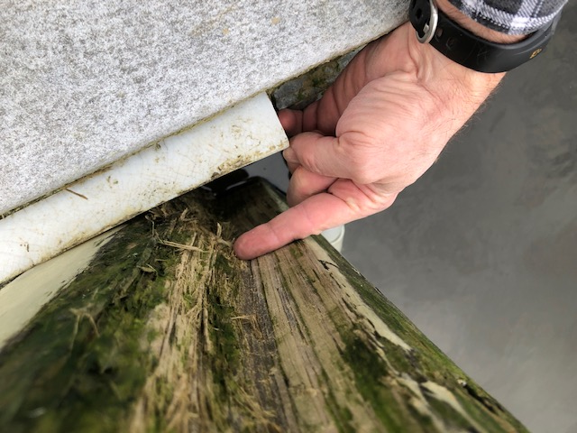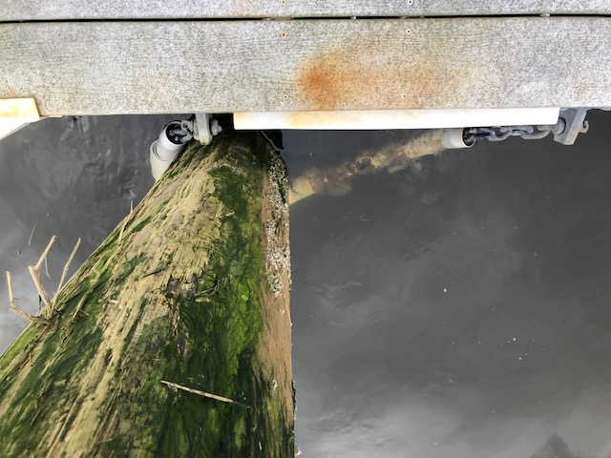
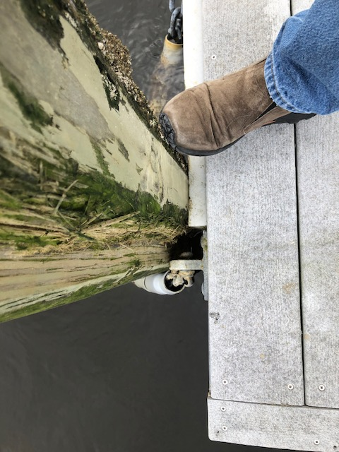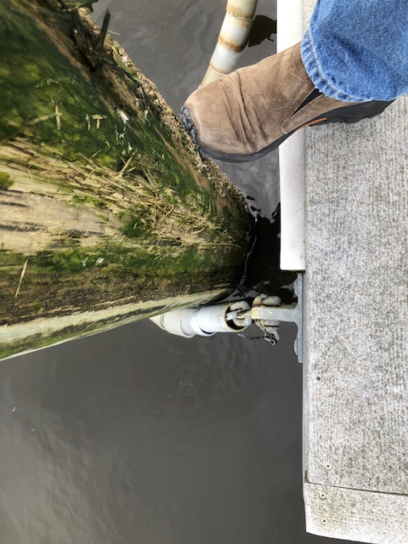
Significant gouge in the piling from bracket
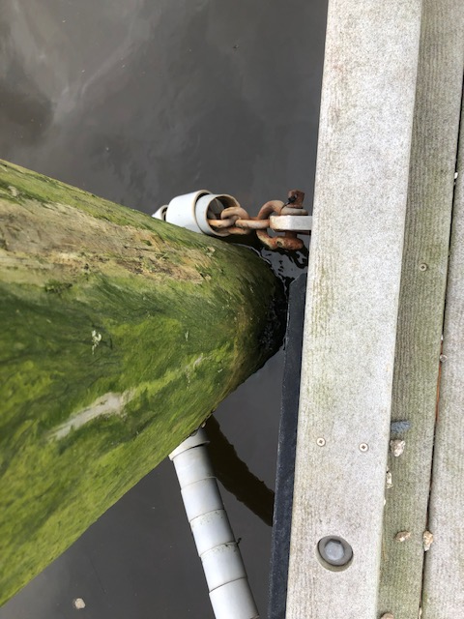
Nylon not aligned with the piling

