Mooring Report
02/09/17

The 23 moorings in the PYC yard were inspected in January with pictures taken and a report written. A couple of the buoys will need new shackles and all will need to be repainted.
- One Little Harbor buoy, 319, was replaced because of its age and coating wear
  - Used the small newish buoy #127 (20.5” A4 size) from Pepperrell Cove
  - A4 is the smallest to use here, water line was about 3” below the center line.
- The Fox Point Little Bay mooring needs to be upsized
  - It is an A3, (17”) which is too small for 35’ of chain.
    - A3 has 121 lbs of buoyancy and there is 116 lbs of chain without the shackles
    - A4 (21”) has 187 lbs of buoyancy and $70 each, Could go with an A5 like PC?
  - The water line on the buoy was at the center of the buoy and Mike C. has reported that sometimes he can’t find it when they are in Little Bay
- Many of the blue IOS buoys are showing signs of age and damage as they are at least 10 years old.
  - They are all top exit and most have damage to the bottom exit.
  - These will probably need to be replaced within the next year
  - One is missing all the screws that hold it together
  - We are researching what to replace them with
    - Probably A5 (27” 396 lbs $140) or A6 (34” 792 lbs $260 each) because of the upsizing to ¾”
      - 3 could use the A5, the other 5 might need A6 or make them all the same size?
      - PCM recommends going with the larger size
- Pepperrell Cove buoys
  - All but the newest smaller buoy were very dirty (Cormorant sittings?)
  - And fairly old but usable for a couple of years, maybe consider replacing?
  - Need to order 1 new A5 to replace the small one that went to LH, $140
  - The mooring numbers are incorrect
    - The PCYC moorings were given new numbers in 2011 but they were never updated
    - Numbers being updated now with the repaint
    - New numbers are 494-499
  - Jerry would like to make the PC buoys more distinctive and easier to find for the transients
    - We talked about it and will be putting a 12” “skull cap” or burgee (see pictures)
    - So now the transients can look for the blue stripe and blue top
- PYC buoys
  - 3 are showing signs of aging where the vinyl coating is very worn (see pictures), 2 are worn
  - These are A7 (39”1345 lbs) and about $390 each

We are hoping to have all the smaller portable white inflatable buoys (9) cleaned and painted by the Spring. These are the 6 from PC, 2 from LH and 1 from LB. The larger PYC and IOS buoys will be done in the Spring at PYC.

The repainting issue on 2016 with PCM has been partially explained. PCM used the incorrect paint on the 8 IOS buoys and it wore off during the season. It seems they missed all the other buoys. We were not invoiced for the painting of any of the buoys. We are moving the initials and the mooring number closer to the top for easier reading.

In 2016 14 chains were replaced, 5 of the 16 were upsized to ¾”. We may have to upsize some of the buoys to compensate for the extra weight, need to keep an eye on the 4 IOS buoys whose chain was upsized with the heavier chain. 35’ chain was 116 lbs is now 186 lbs, 50’ chain goes up 100 lbs.

The mooring report excel sheet was updated with the 2016 data from PCM.

Estimate to replace 15 buoys: $4300
May want to replace 5 PC buoys too though I’ve cleaned and painted two: $700.

Condition of the IOS Buoys:

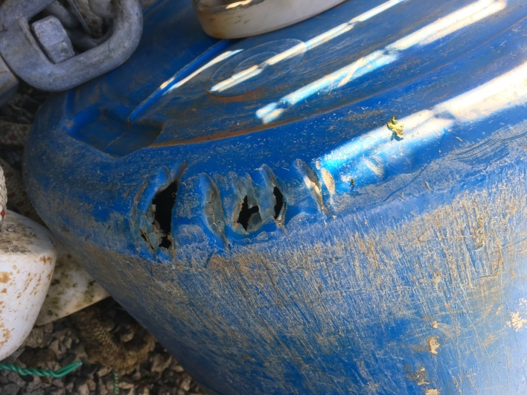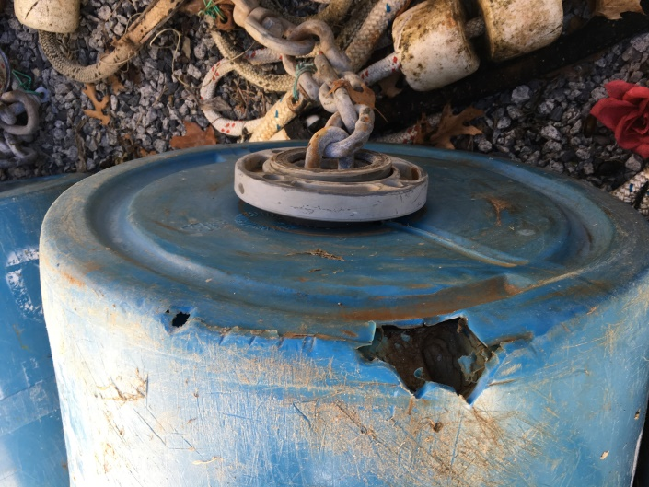

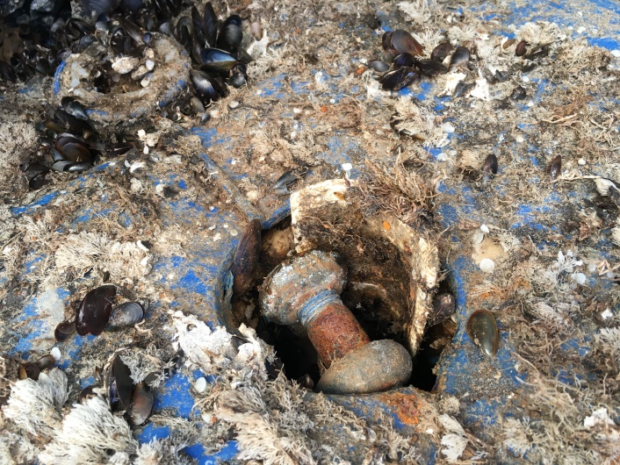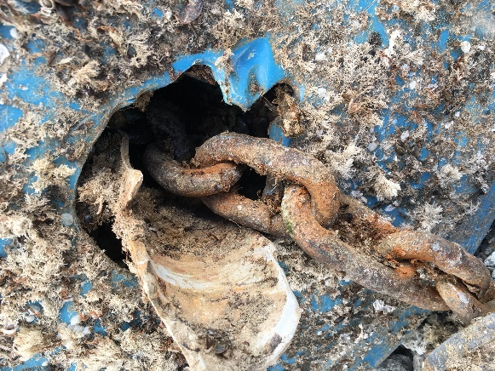

Broken bottom exits

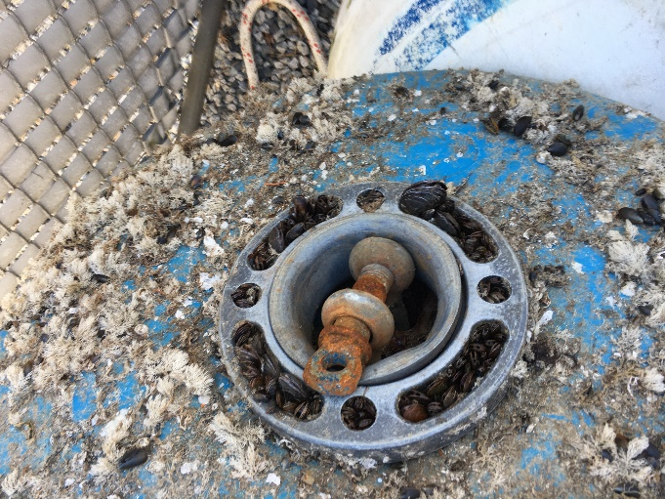
Good bottom exit

PYC buoys
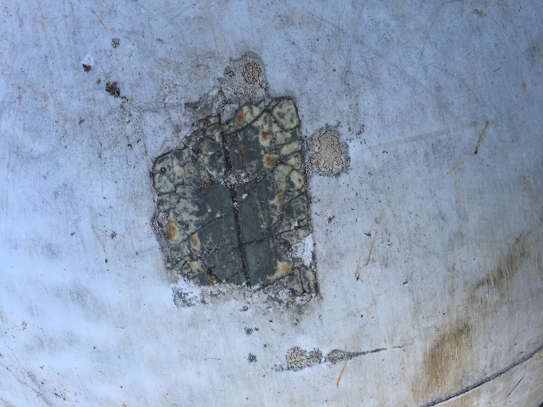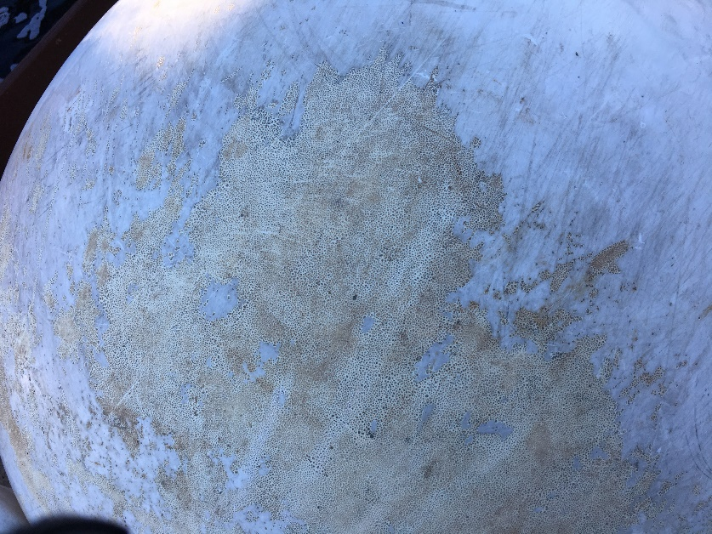
140 203

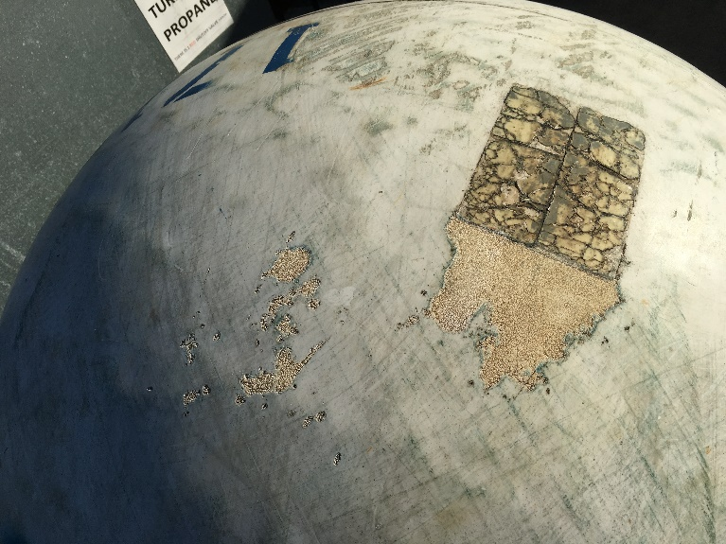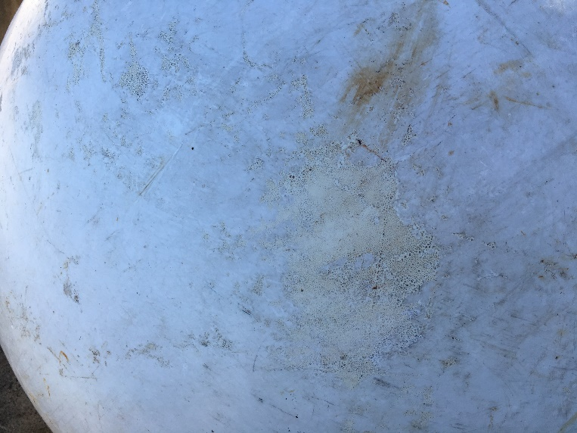

1716 2259

Potential Replacements
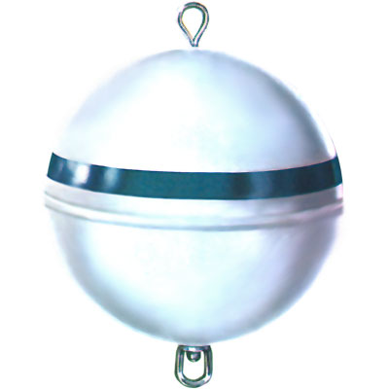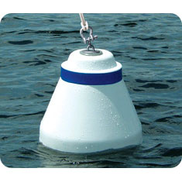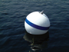
Jim Buoy 30” Taylormade Tapered 30” Taylormade TC3 30”
$365 $430 $395

Polyform: A6 34” ~$260 each

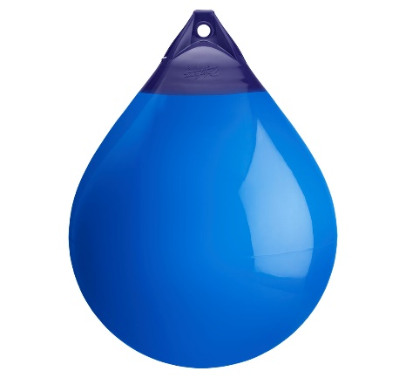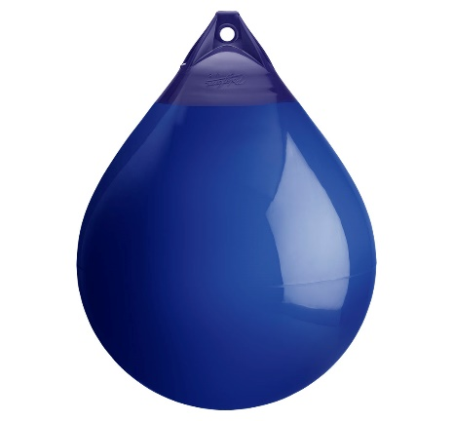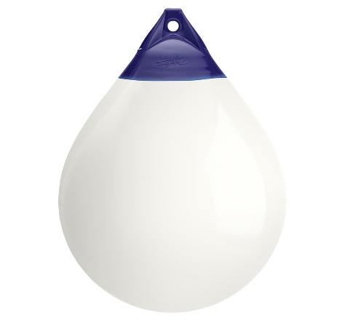
Blue Cobalt White

Cleaning and Repaint
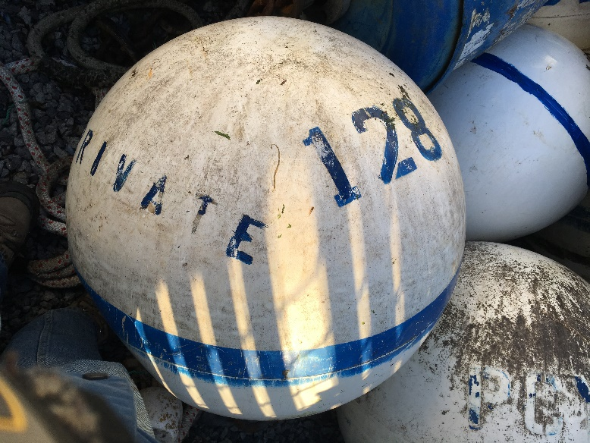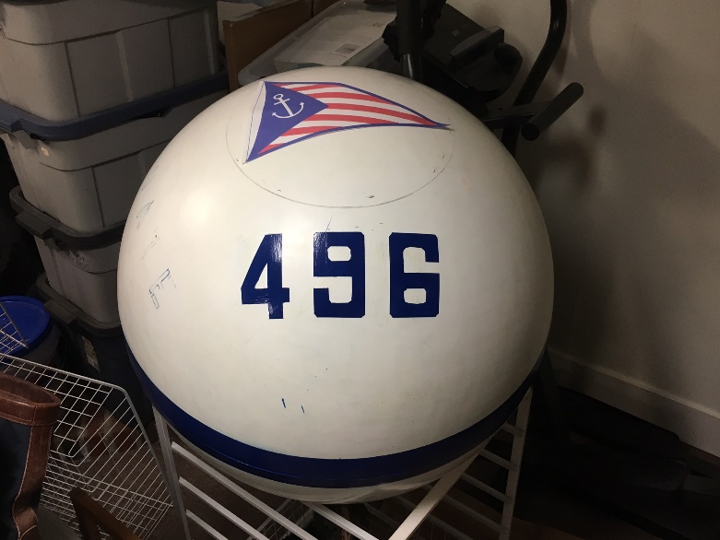
Before with old number After with new number and burgee option
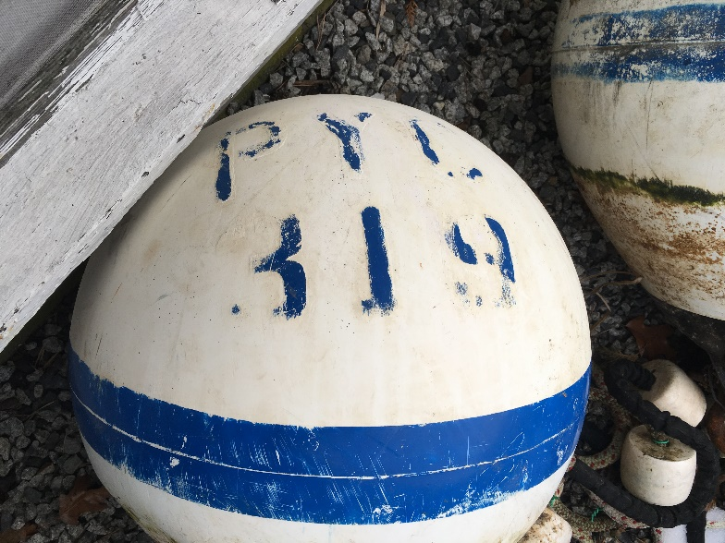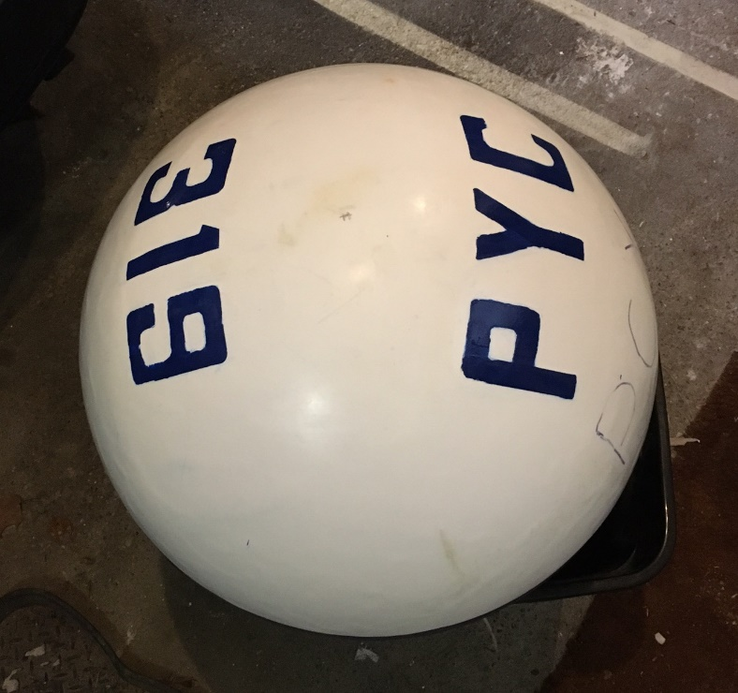
Before (retired) After (was PC 127/497)

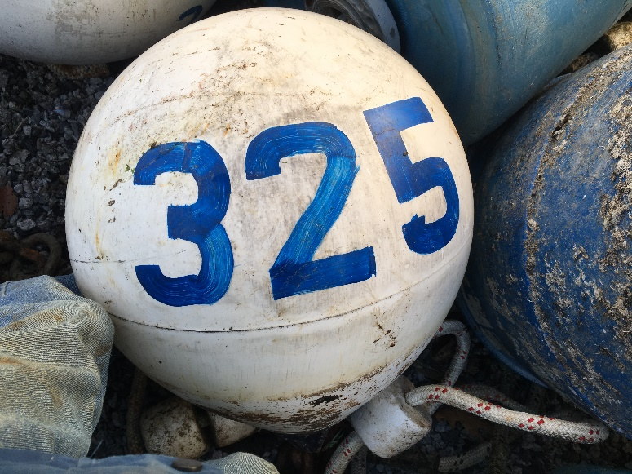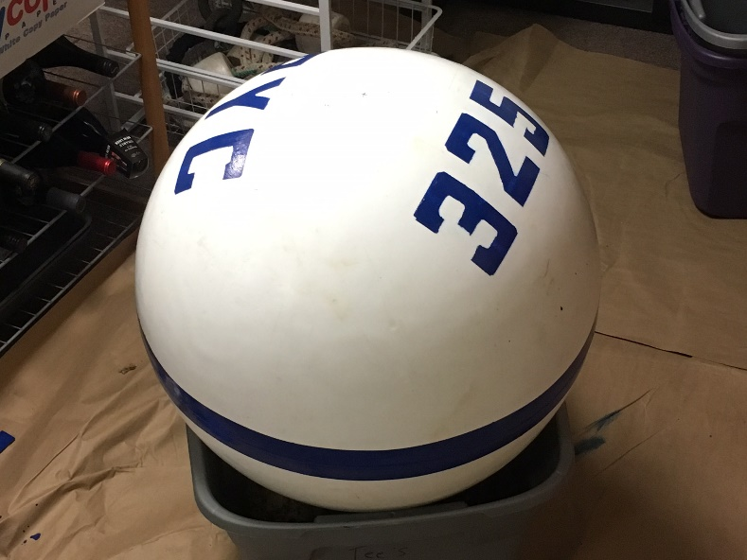
Before After

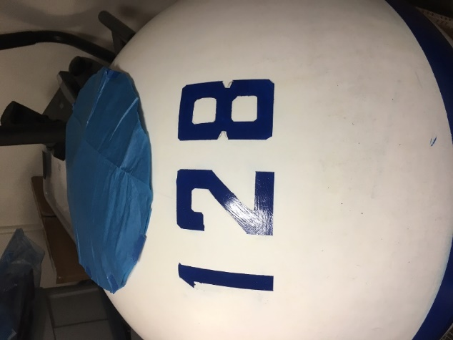
Skull cap version

