The Care and Feeding of Moorings
1/31/2017

Tools needed:

Removing and storing pennants:
- Sharpie
- Small 4” tie wraps
- 1 ¼ Paper Key Tags
- Replacement sizing wire – vinyl coated?
- Pliers
- Small long bars for leverage

Cleaning:
- Greased Lighting
  - Be careful with it, it is probably not environmentally friendly
- Soft Scrub with bleach
  - Ajax/Comet or Bon Ami also work but not as well as the Soft Scrub
  - One bottle lasts about 4 buoys
- Lacquer thinner
  - For taking paint off
- Mineral spirits
  - For getting and remaining grease and grim off before a painting
- ??
  - For removing permanent marker
- Cleaning Brush soft to medium bristle stiffness
- Paper towels
- Scraper
- Box of disposable gloves

Painting:
- 2” 6 pack of throw-a-way brushes
- 2” Painters tape – the better grade that it will stick to the vinyl
  - 3M Multi-surface tape
- Flexadel Inflatable buoy paint
  - Make sure it is the PVC and Inflatable version! NE Marine has the paint
- Pencil
- Tape measure
- 4” Stencils about $5 at Lowes
    - Use the 0 (zero) to make a second C for PCYC (See pictures)
- Plastic tub
  - To keep the buoy upright while painting

The Process
Remove the pennants in the Fall?
- Take the pennants off in the Fall and mark the pennant with the buoy number
  - Place the pennants in the shed out of the weather
Spring
- Fill the buoy with 2 psi of air. 2 psi is enough so pressing on the buoy take some pressure to push it in.

Cleaning
- Scrap any of the big stuff off, be careful and don’t damage the vinyl!
- Greased Lightning treatment
  - Gets the initial layers of grim and bird poop off
  - Spray on
  - Let set a minute
  - Scrub brush the buoy
  - Let set a minute
  - Wipe off with paper towels
  - Wash brush
  - Many warning on the label!
- Soft Scrub treatment
  - Squirt it on in sections
  - Scrub brush the section
  - Do the other sections
  - Let set a minute
  - Wipe off with paper towels
  - Wash brush
  - Scrub a little more for tough areas or do it a second time
- Cleaning takes about 30-60 minutes depending how dirty the buoy is

Painting
- Hopefully the paint will last 3-4 or more seasons
- If you need to strip the paint off, use the Lacquer thinner, it is quicker
  - You will need clean portion of the paper towel to get it clean
  - The Lacquer thinner will smear the paint if the rag is not clean
  - Mineral spirits will eventually work but it is a lot slower process
  - Wipe the buoy down with mineral spirits after using the lacquer thinner
- Center stripes
  - Should be about 2” wide
    - Measure 1” above and below the center seam
      - Mark with a pencil every 6”-8”
  - After marking apply the 2” painters tape around the buoy
- Lettering
  - Put the mooring number and the Club initials close to top
    - Makes it easier for the boaters to see
    - They don’t have to drive around the mooring looking
  - Taping the stencils down on the round buoy and then paint doesn’t work very well!
    - The paint bleeds under the stencil
  - Tape the stencils down then mark the outline with a pencil
    - The pencil will wear off if you don’t happen to get paint on it
  - Remove the stencil and then tape the outline
    - Takes about 30 minutes to tape off both number & initials
    - It frees up the stencil to do other buoys
    - Very minimal painting running under the tape this way
    - Make sure you press down on the tape along the edges
    - You will need to do some custom cut outs of tape
      - Place the stencil on the tape and mark the custom areas
        - Inside the P, Y, C, 8, etc
        - Apply the cutout to the areas as needed
  - Once all the available buoys are prepped and taped Paint them
  - Let the paint be dry to the touch, about 15-30 minutes
  - Repaint with a second coat
  - Remove tape about 30 minutes after the second coat

Cleaning and full repaint takes about 2-2.5 hrs per buoy depending how dirty they are

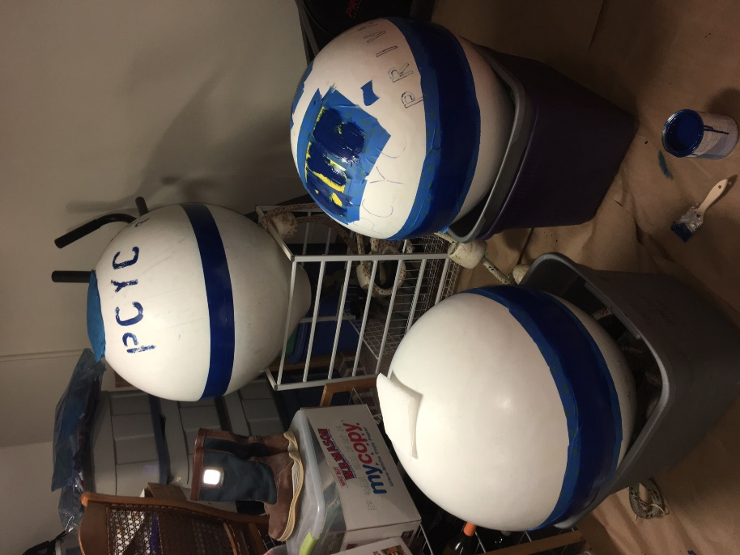 Tub to hold the buoy while painting

Painting over stencils: Bad way to do this, much bleeding under the stencil

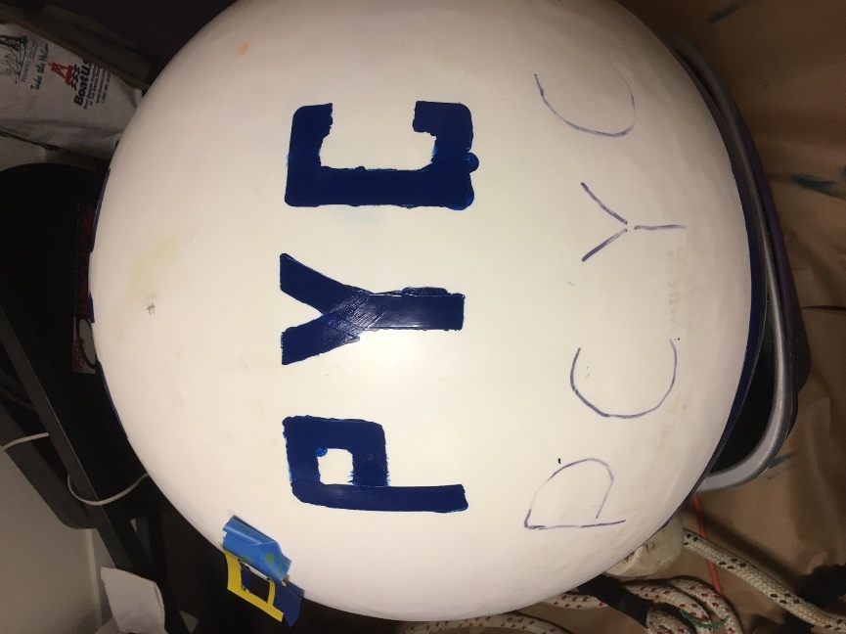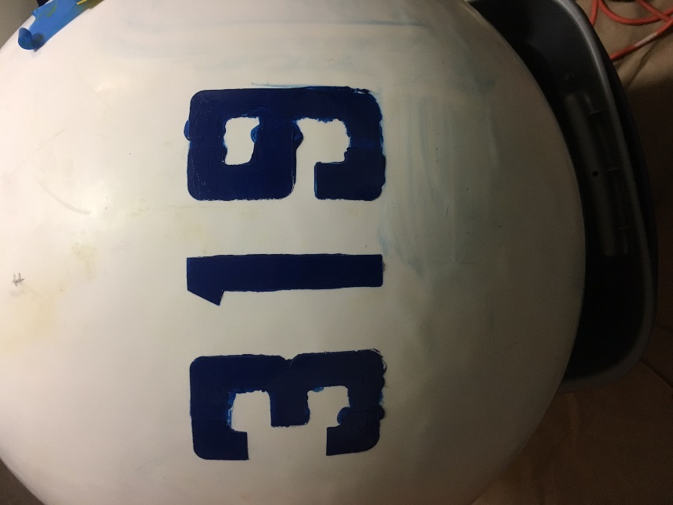

Outline stencil with pencil and tape the outline: Much better, very little bleeding under the tape
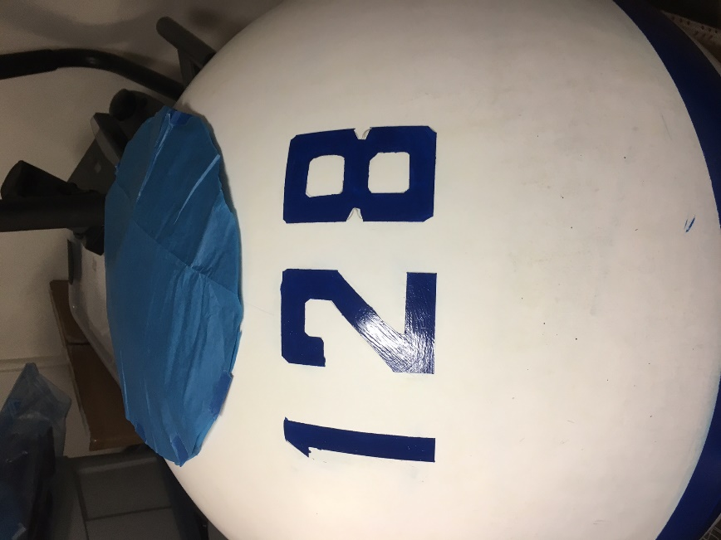
PCYC: Use 0 and cut a push out piece to close in the 0 to make a second C
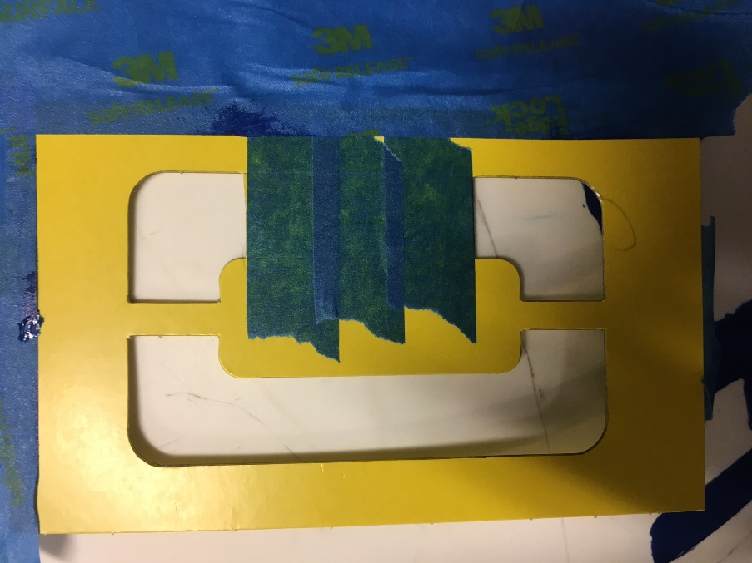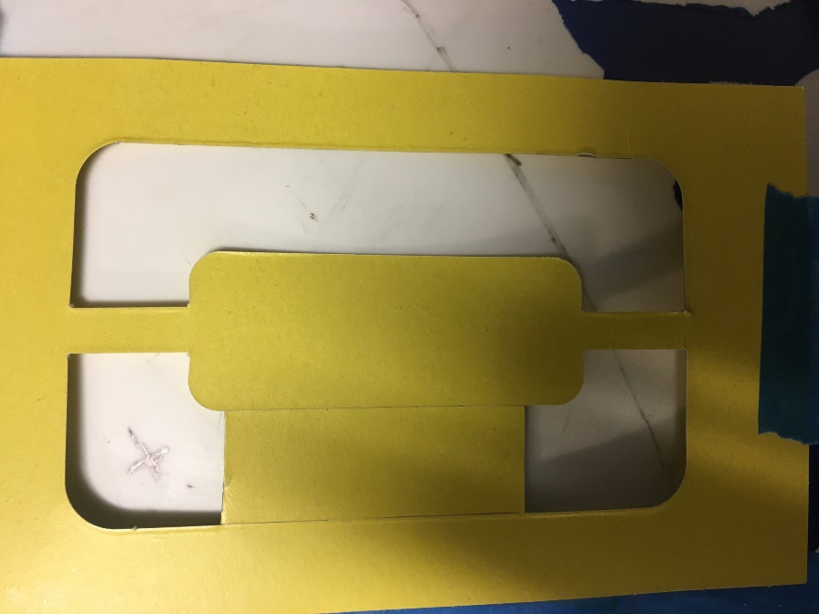

Stencils taped on buoy for tracing
