PYC Fuel System Inspection
6/3/16 amended

Attendees:
Dick Blidberg, Roy Briscoe, Dan Gingras , Jerry Goldfarb, Nancy Gulley and Tim Stone from StoneHill Environmental.

Purpose:
To view the readily accessible areas of the PYC fuel system, look for deficiencies and get recommendations for repairs or upgrades.

Tanks:
- All the covers were lifted and the immediate areas under the covers were inspected.
- The large metal sump covers are heavy and need two people to remove them

Diesel storage tank
- Water was noted in the sump area and the ingress appears to be coming from the electric conduit. Water was seen dripping from same.
  - Further investigation as to where the conduit goes and why there is water in it.
  - See pictures
- Deterioration noted to the metal walls of the riser
  - Further investigation needed for replacing this before it eventually collapses.
  - See pictures
- Split noted in the neoprene seal of the plastic sump which could allow possible water ingress
  - Recommend repair by regluing neoprene or replacement of gasket. See photos 2978 and 2985
4. Small amount of diesel fuel in fill spill bucket. See Photo 2982. Inspect regularly and have sorbent pads available to clean up spilled diesel or gasoline in fill spill buckets.

Diesel sump Fuel spillage
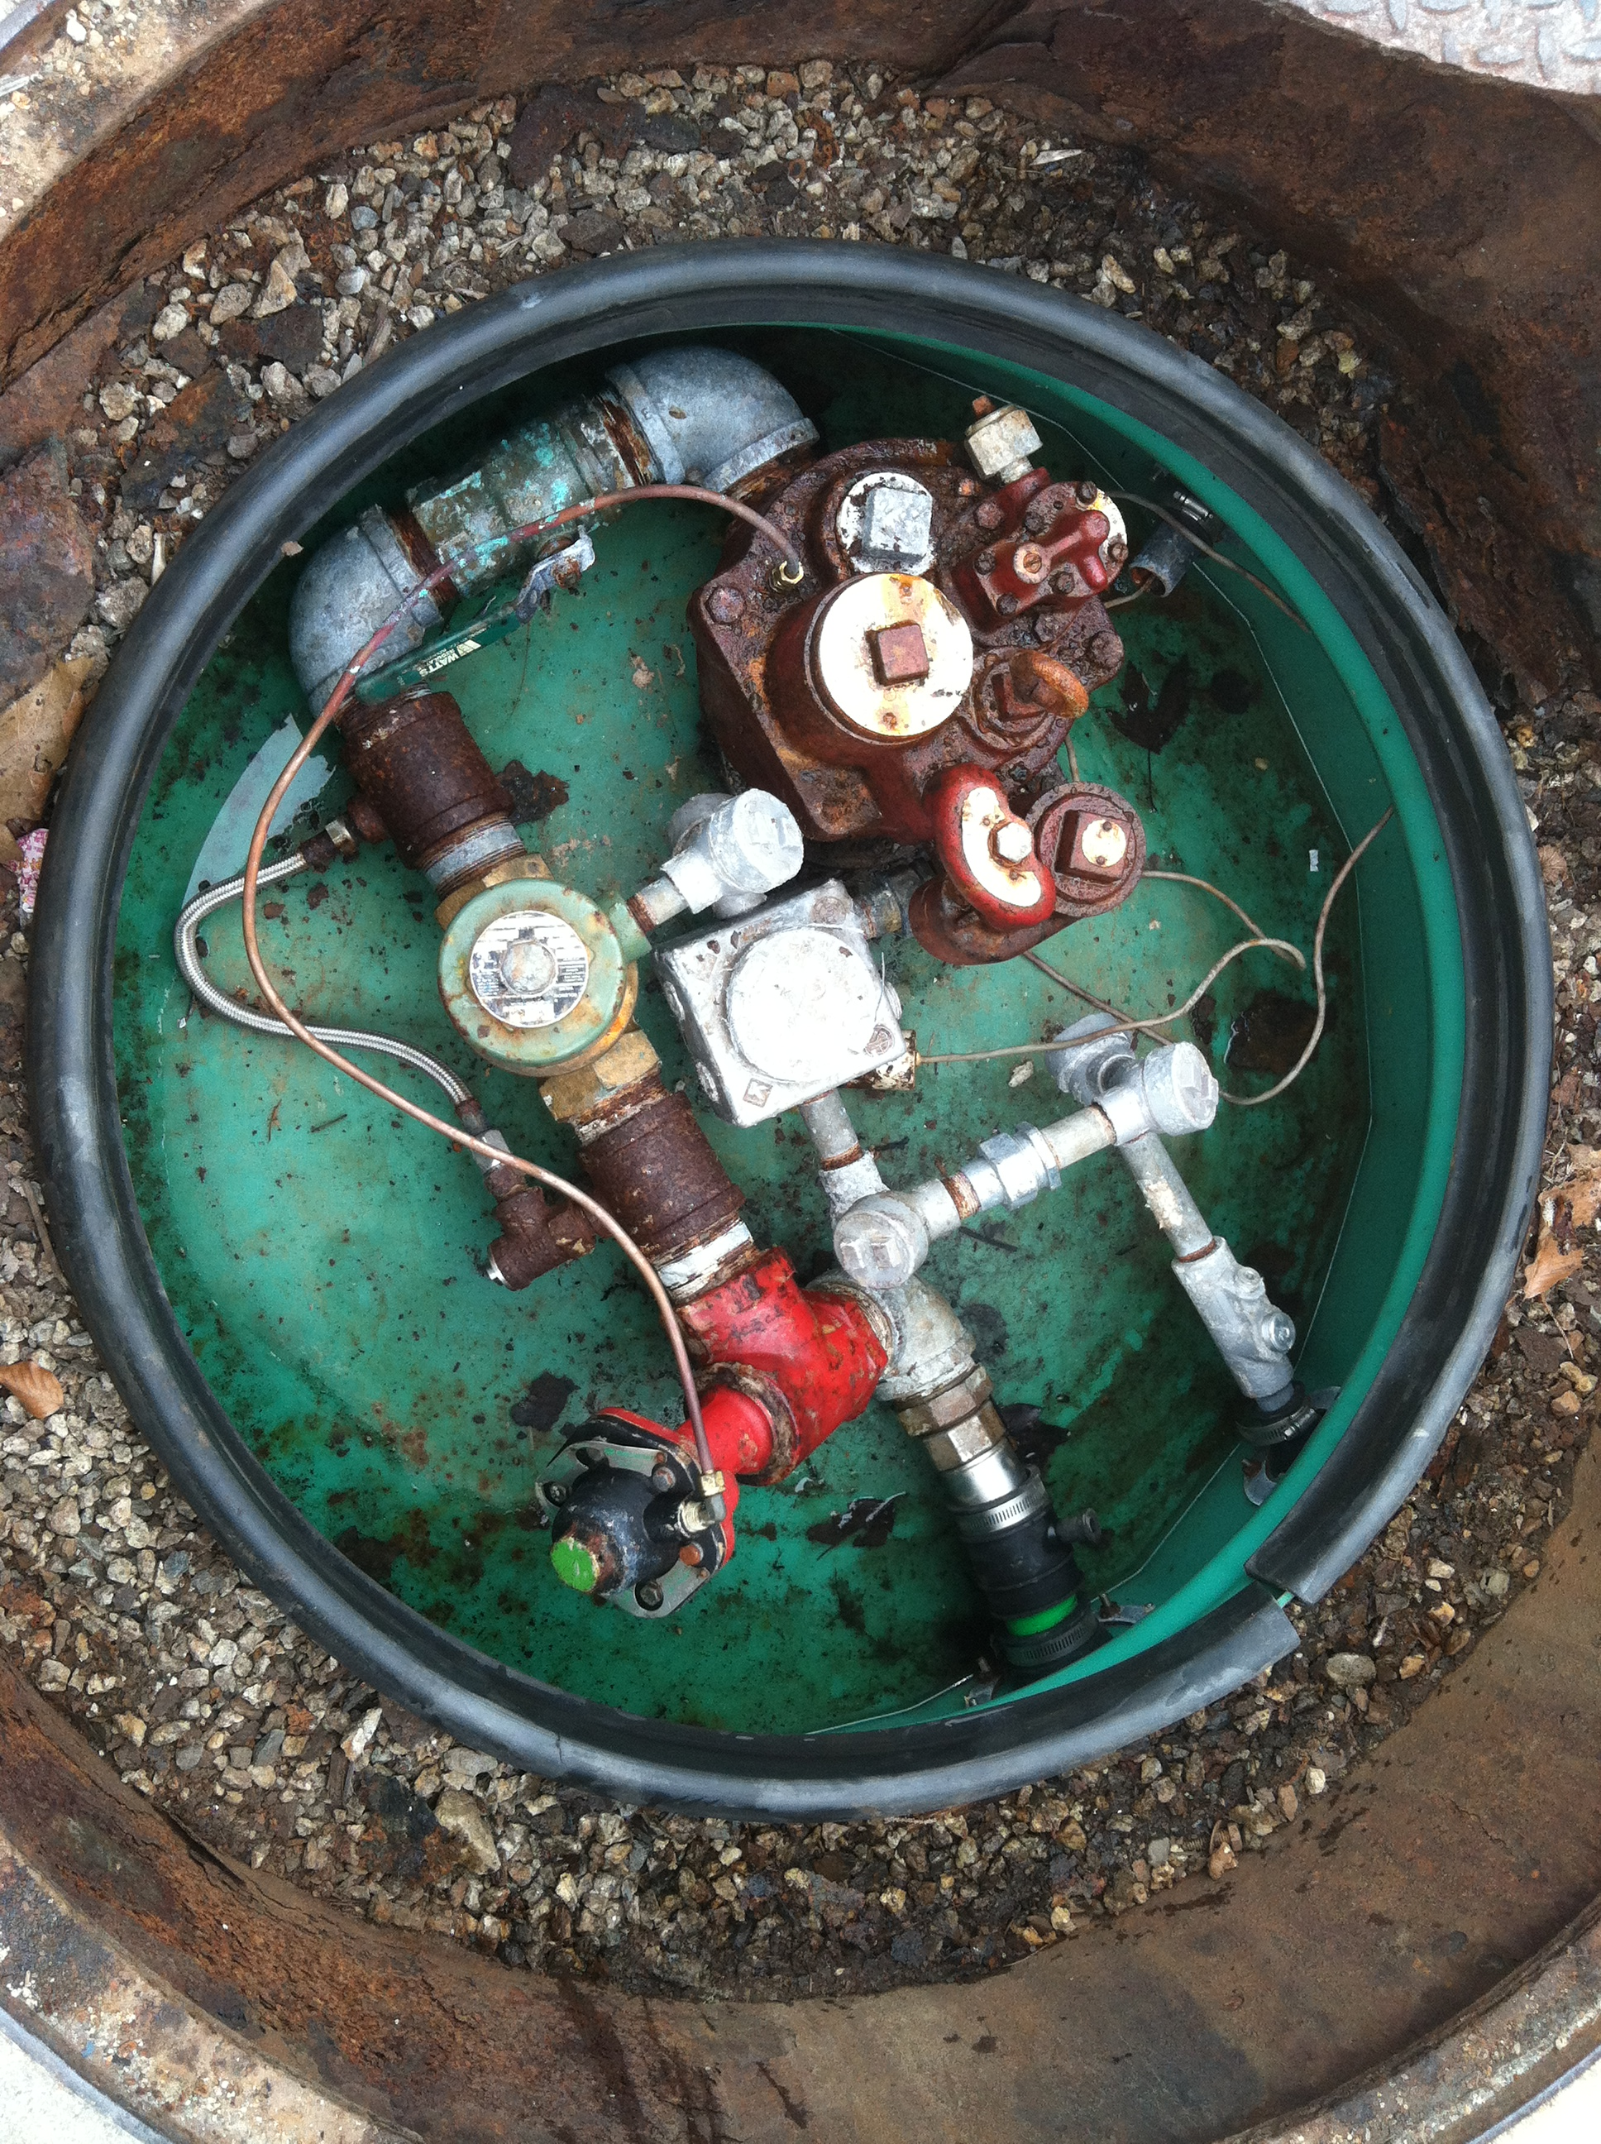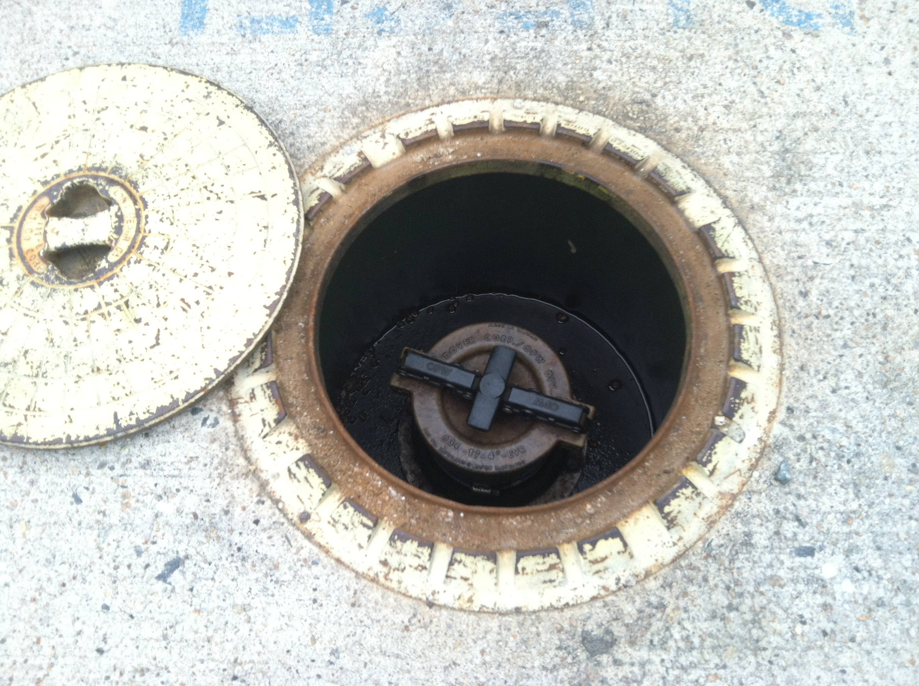

Diesel sump and electrical conduit with water Diesel sump riser deterioration
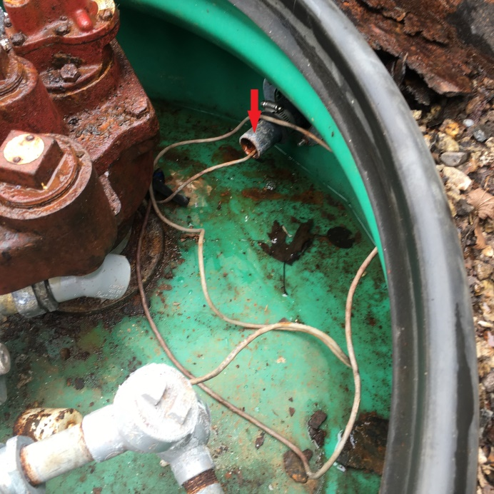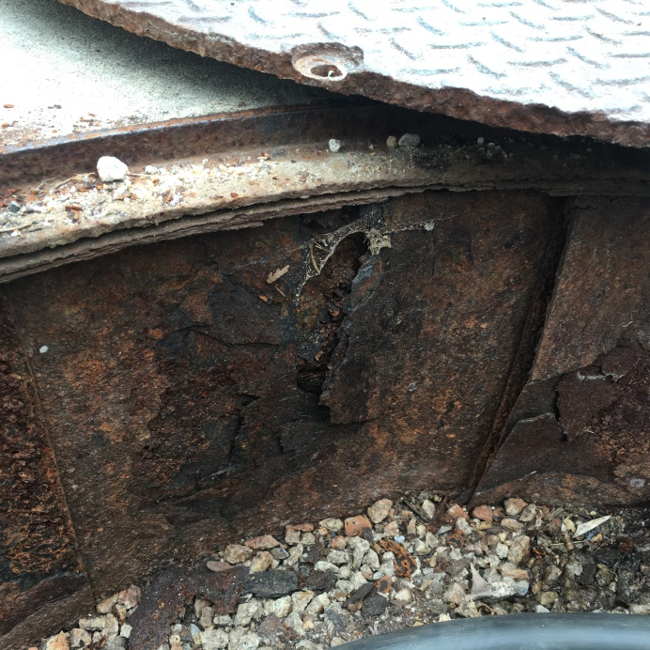

Gas storage tank
- Sump appears dry
- Some surface rust noted on the connectors, could be due to condensation

Pier sump:
- Water was noted in the sump. Cover neoprene gasket split. Re-glue or replace. See photo 2970
- Metal frame rusted and broken
  - See picture
- The rubber gaskets on the incoming West side are cracked and dried out, the metal gasket flange is rusted.
  - Recommend replacement
  - See picture
- The rubber gaskets on the outgoing North side are deteriorated and split
  - Recommend replacement
  - Probably the source of the water ingress
  - See picture
- Loose hose clamp
- Because of the close proximity of the sump to the high water, recommend some sort of device to make sure the sump cover and the access hatch in the pier deck do not come loose and float off
- The electrical conduit (for the shut offs?) and connectors and gaskets are deteriorated
  - Recommend replacement
- Screws too long and protruding on decking cover

Pier sump
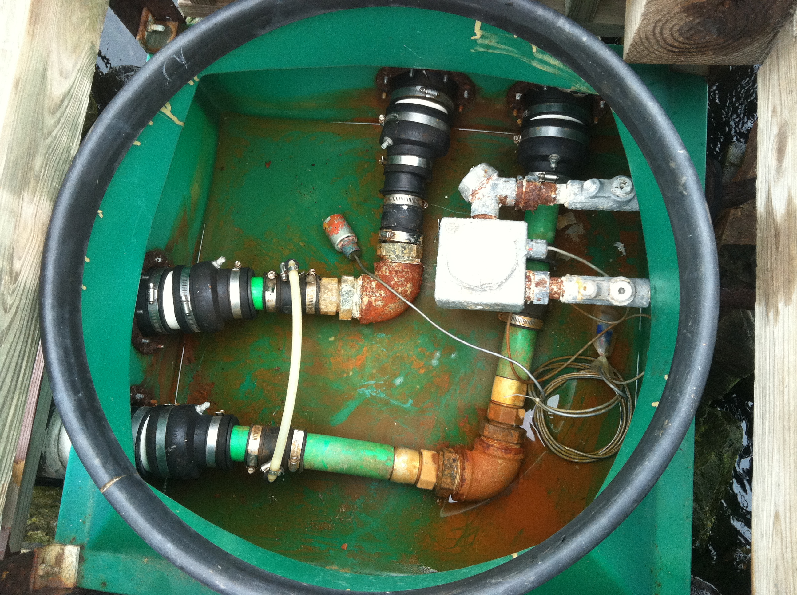

Rusted and broken frame Deteriorated gaskets – West side
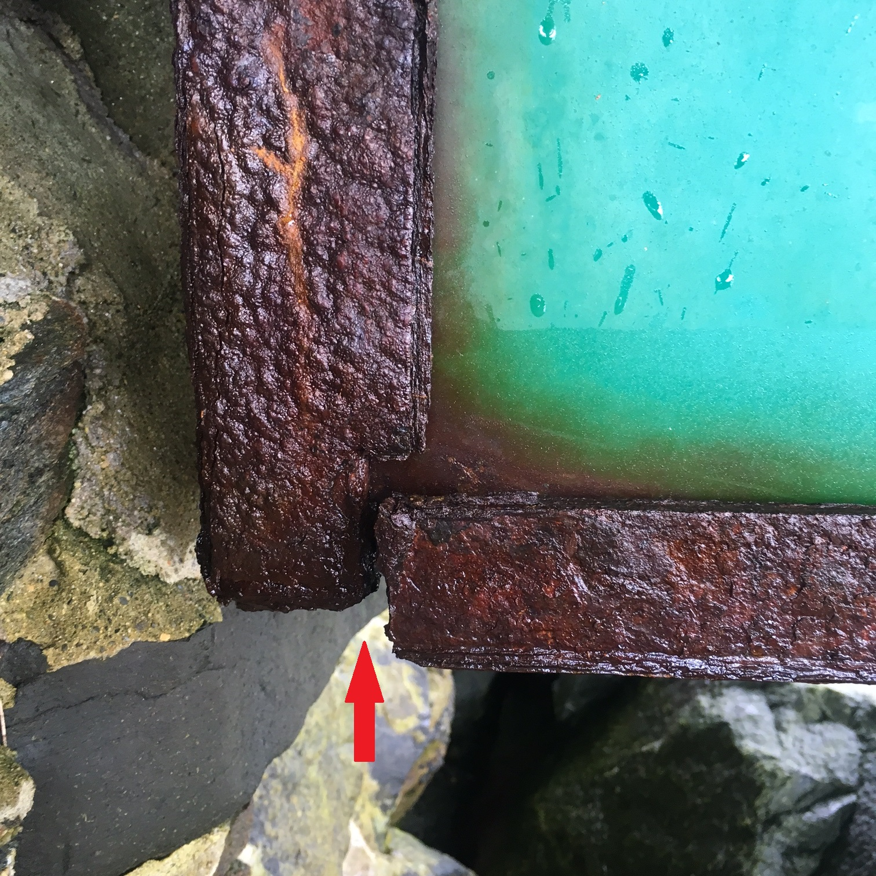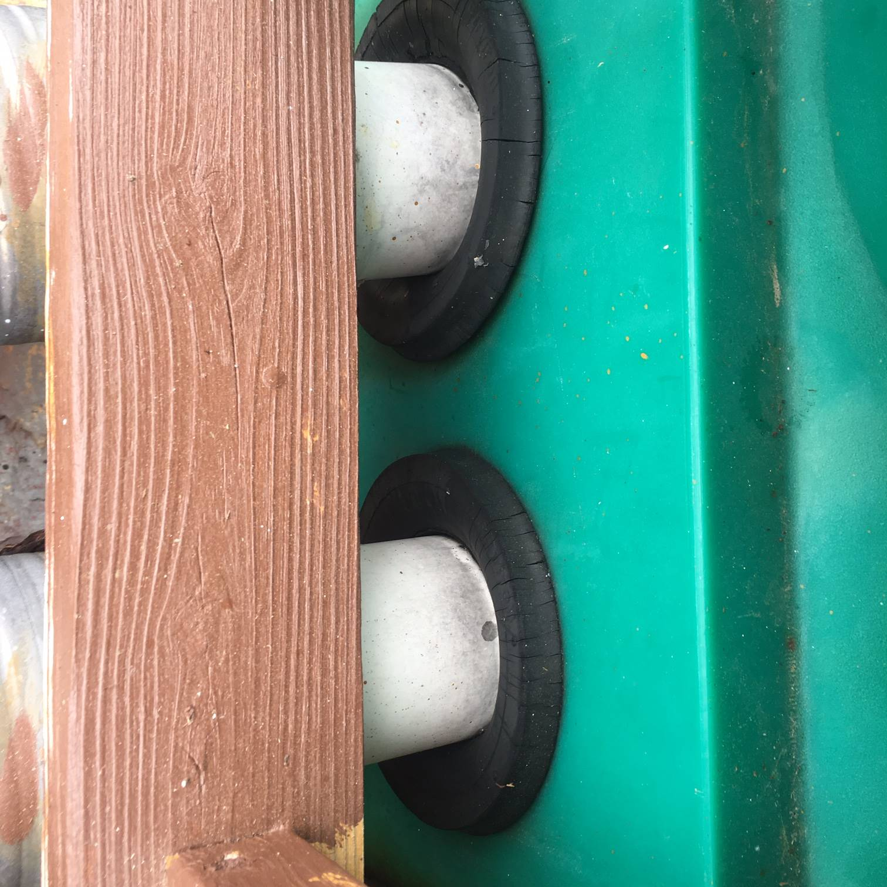

Split, deteriorated gaskets and loose hose clamp Electrical conduit and gaskets issues
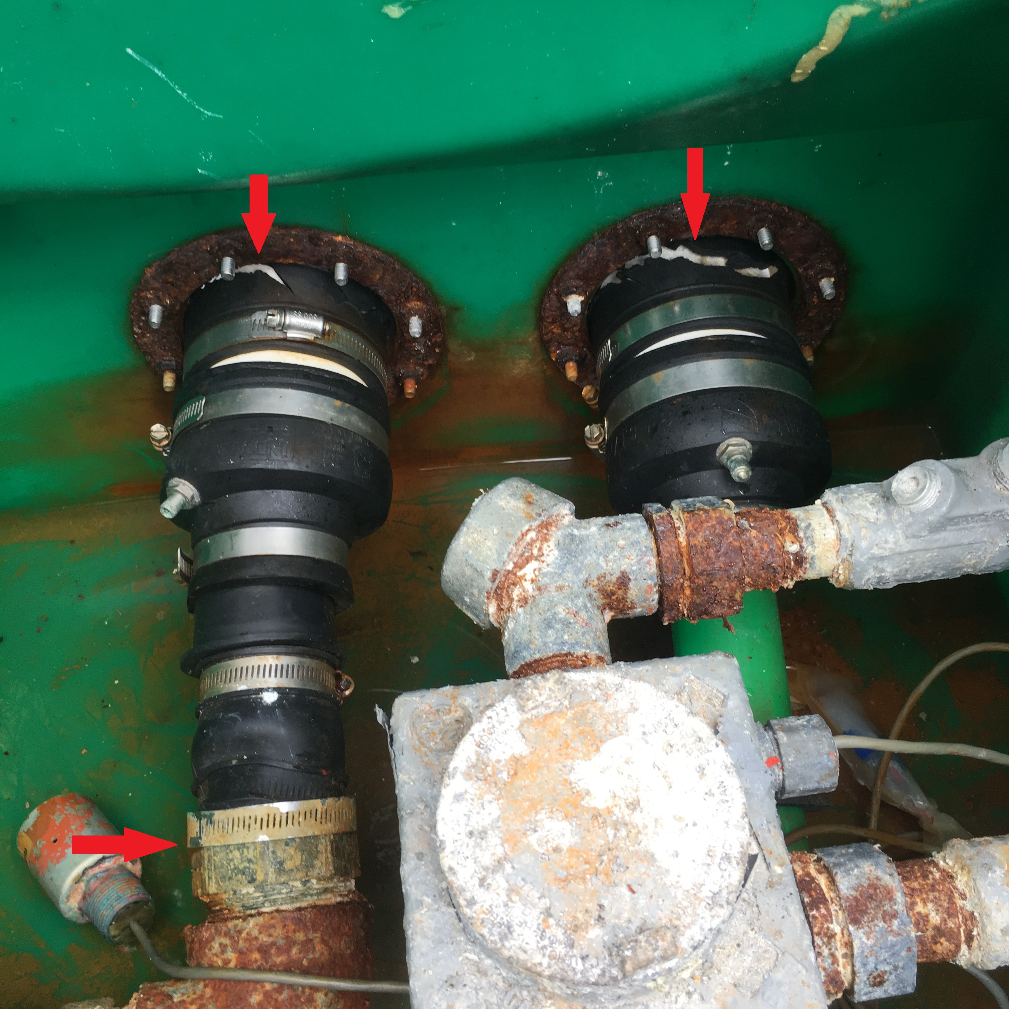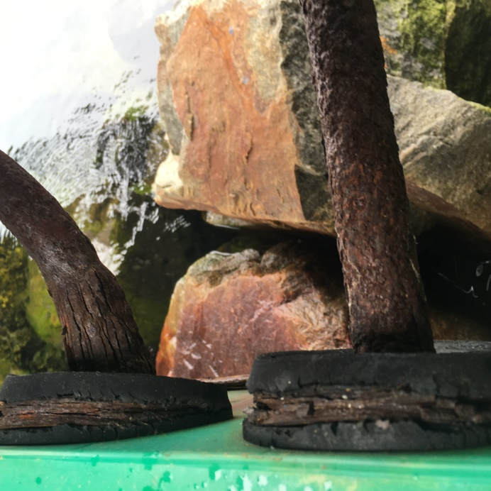

Fuel pump:
- Loose copper tubing hanging out of case in two places
  - Recommend removing not used
- Sump with deteriorated gaskets

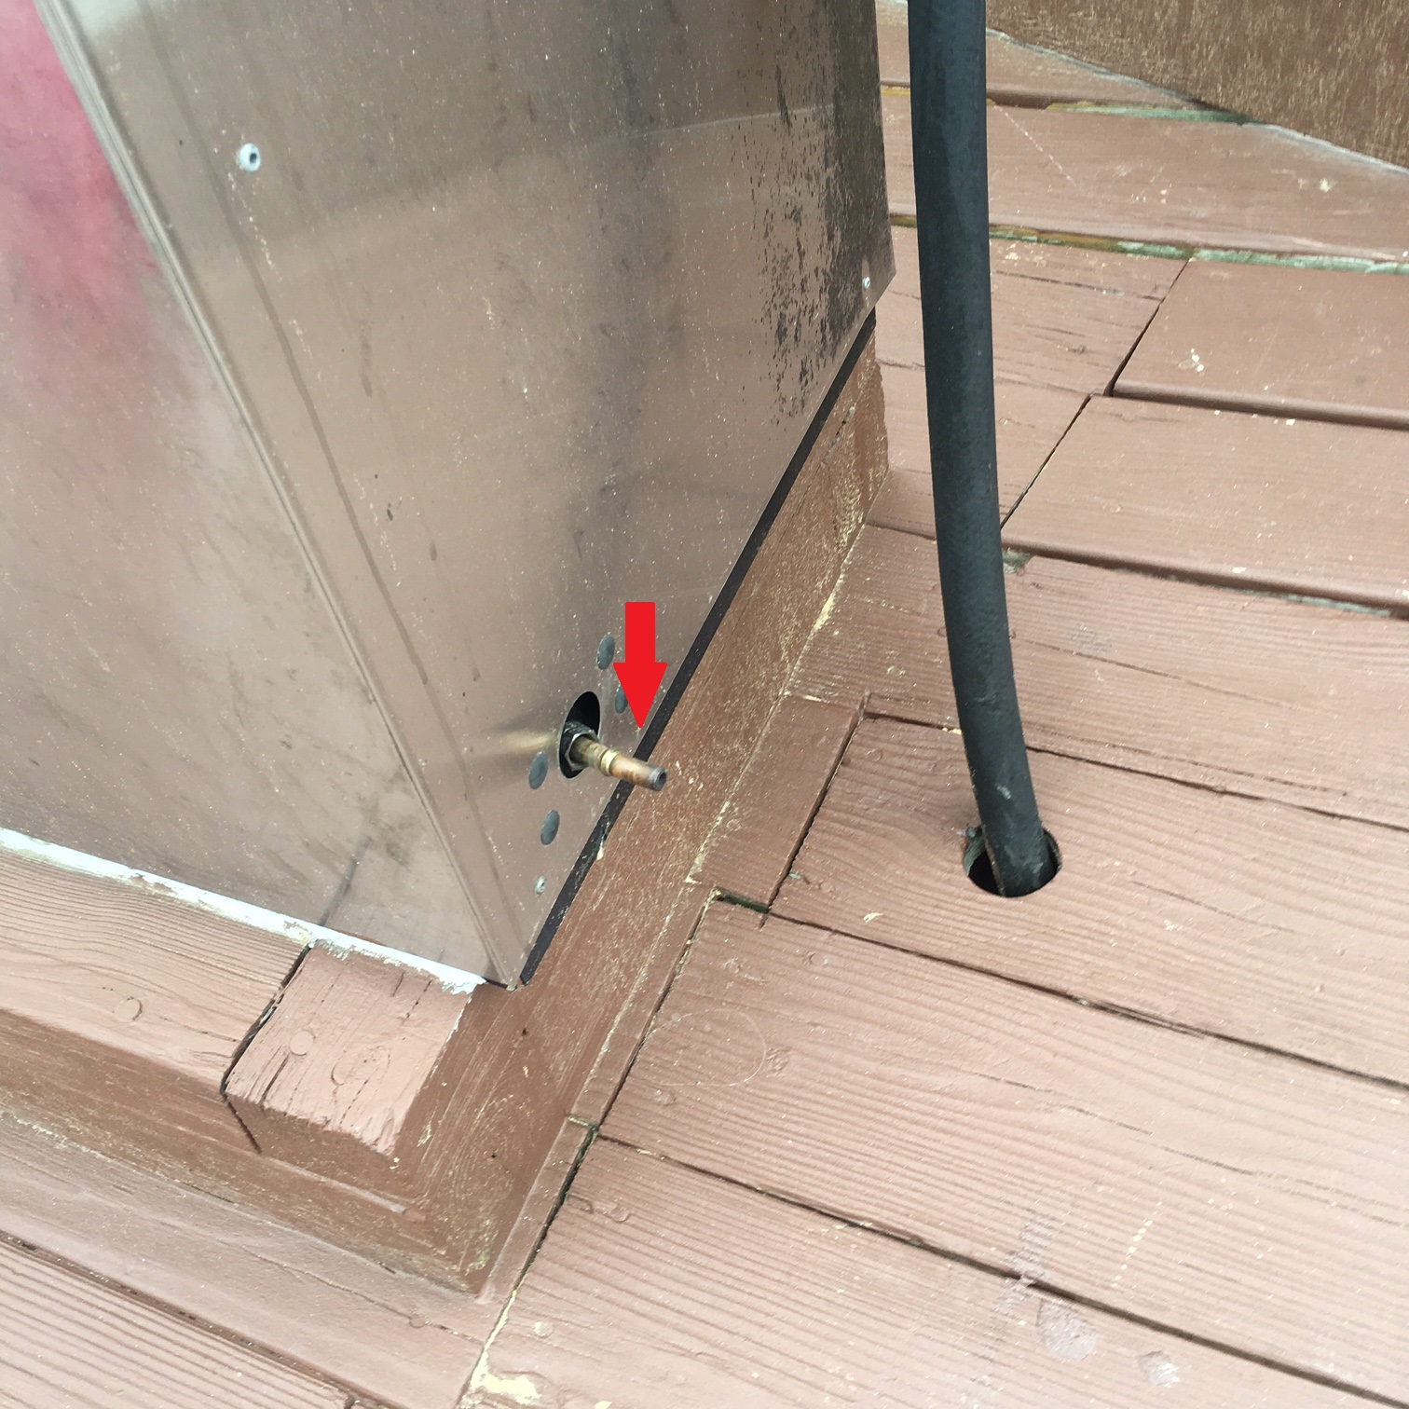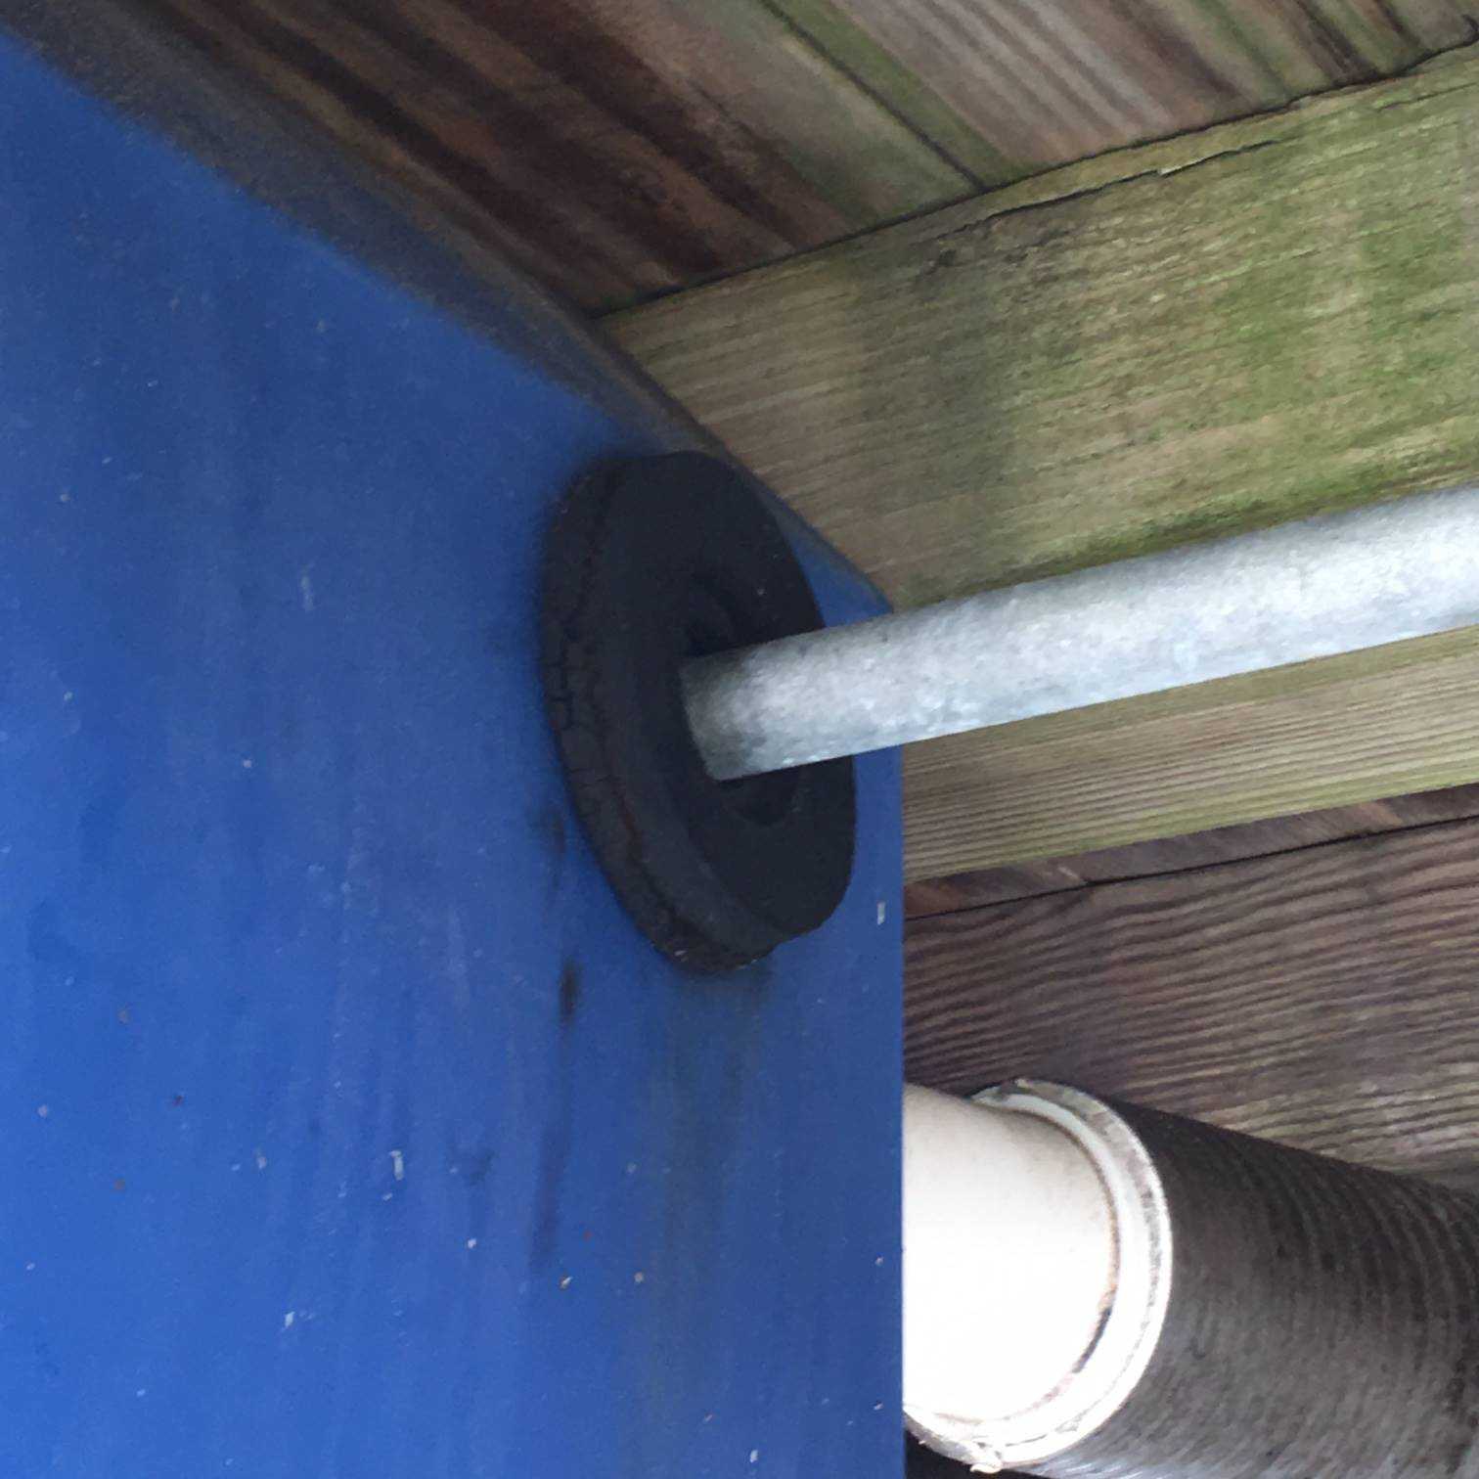

Dock reels:
- Emergency Pump Shutoff Switch
  - Requires a clear identifying label, paint board
  - Free floating wire should be attached
  - Electrical box showing signs of corrosion
    - Recommend replacement
- Loose ground wires. Tighten
- Loose and corroded mounting bolts and no lock nuts. Replace with Nyloc nuts and washers
- Fuel hoses rubbing against dock leaving marks and debris. Cover section of hose in contact with dock with chafe protection see photo 2974
- Diesel fuel sign screw not stainless steel
- Fire extinguisher bracket loose
- Needs more attachment points, wave action causes it to rock

Shut off: Wire, box and no label Fuel hose residue
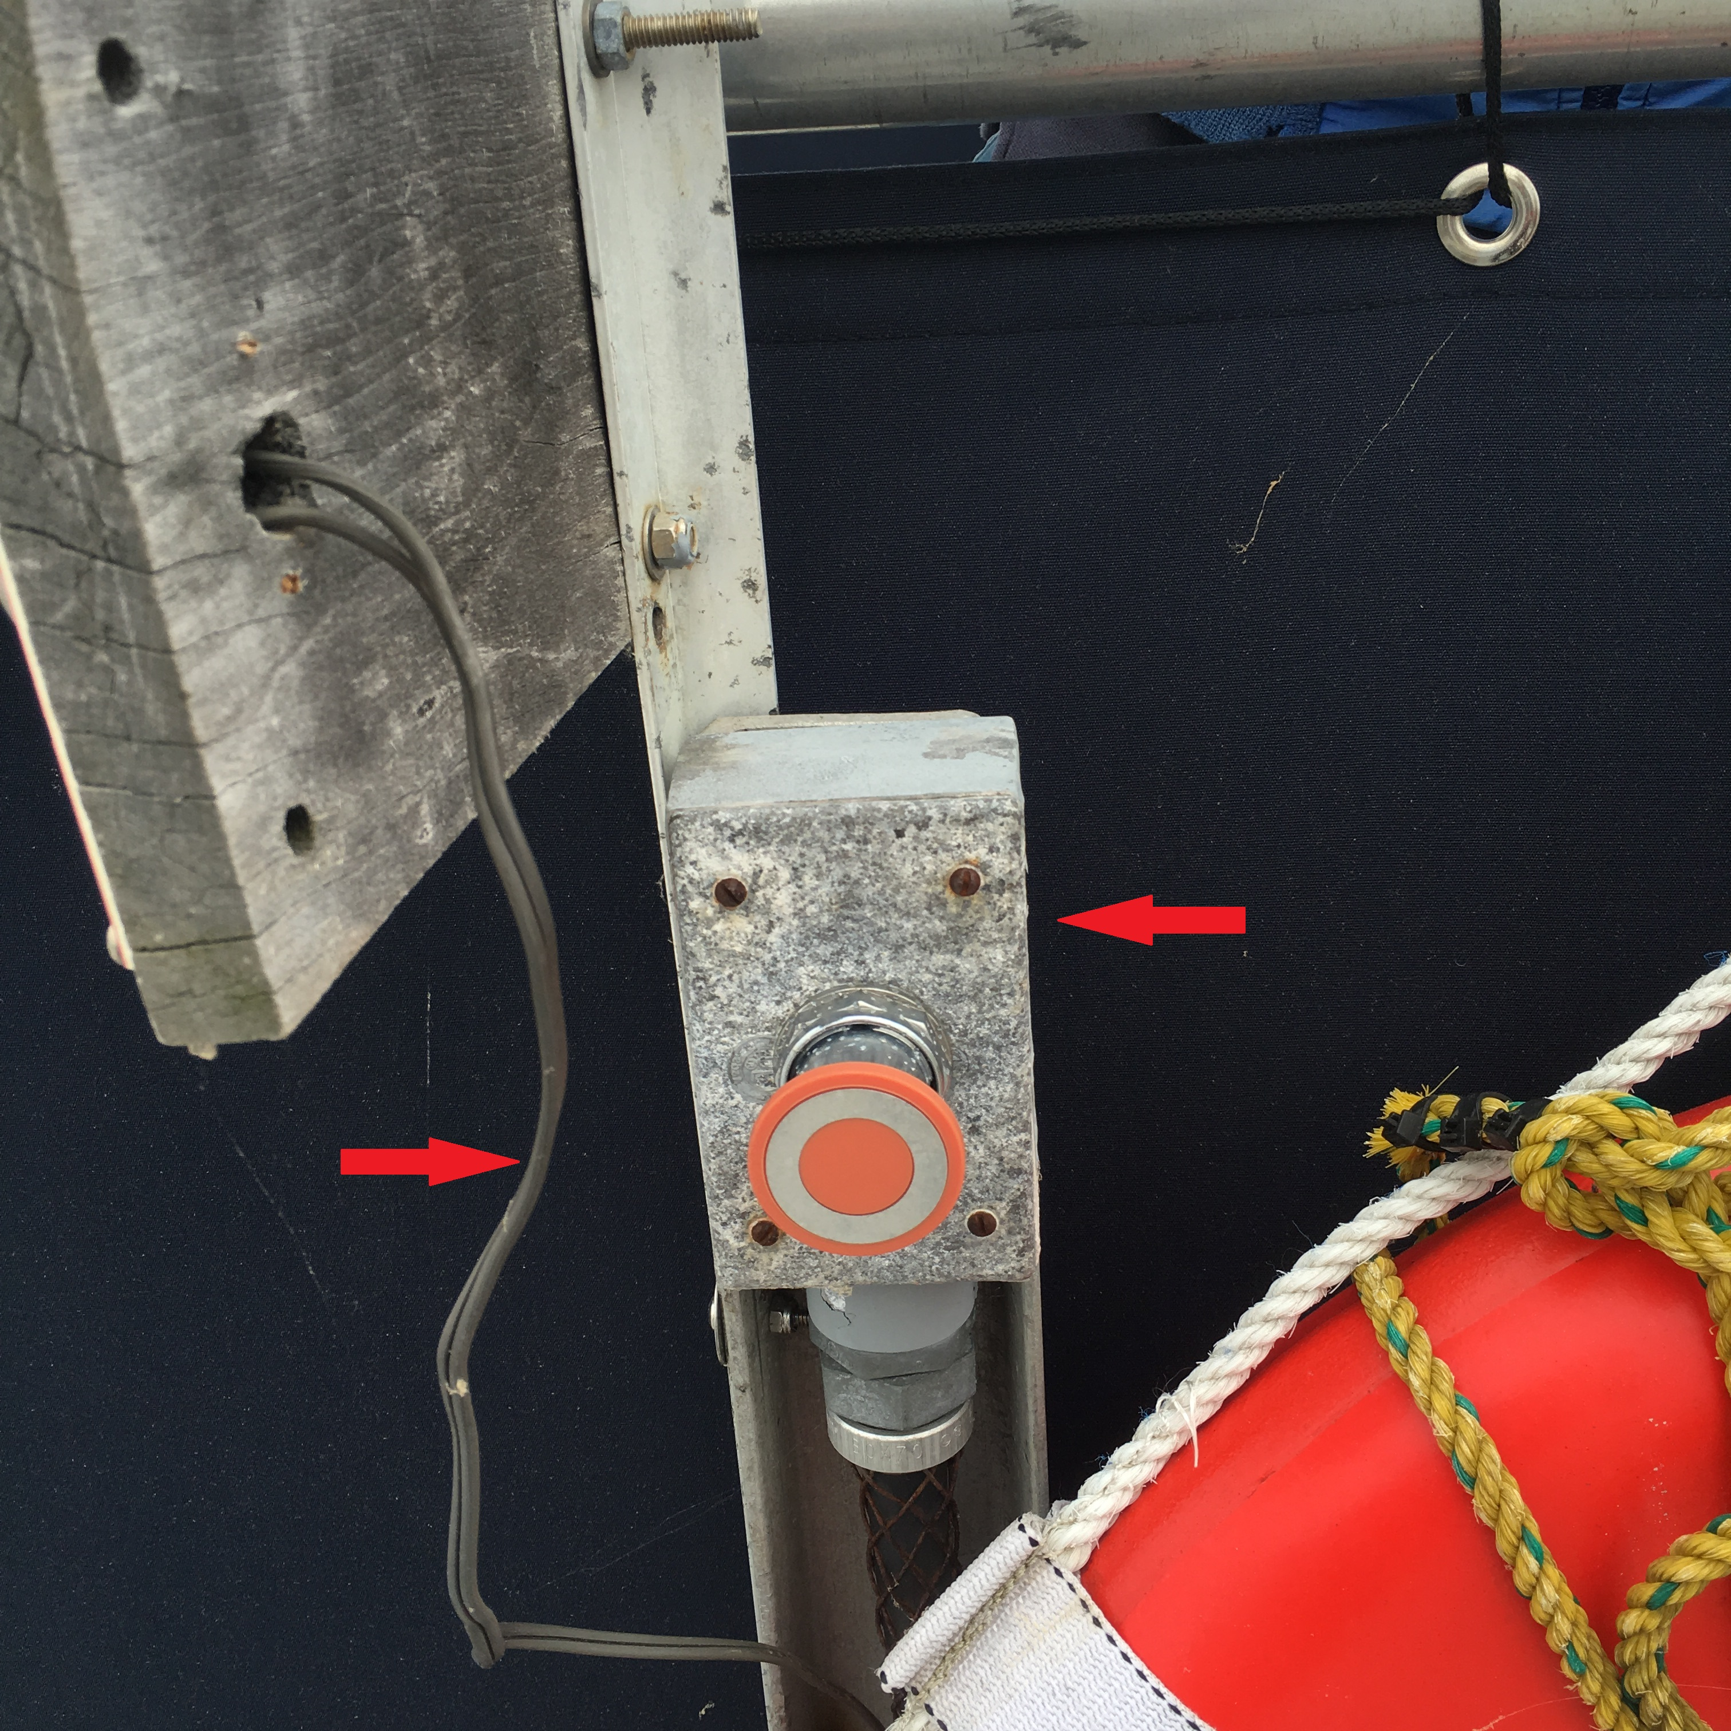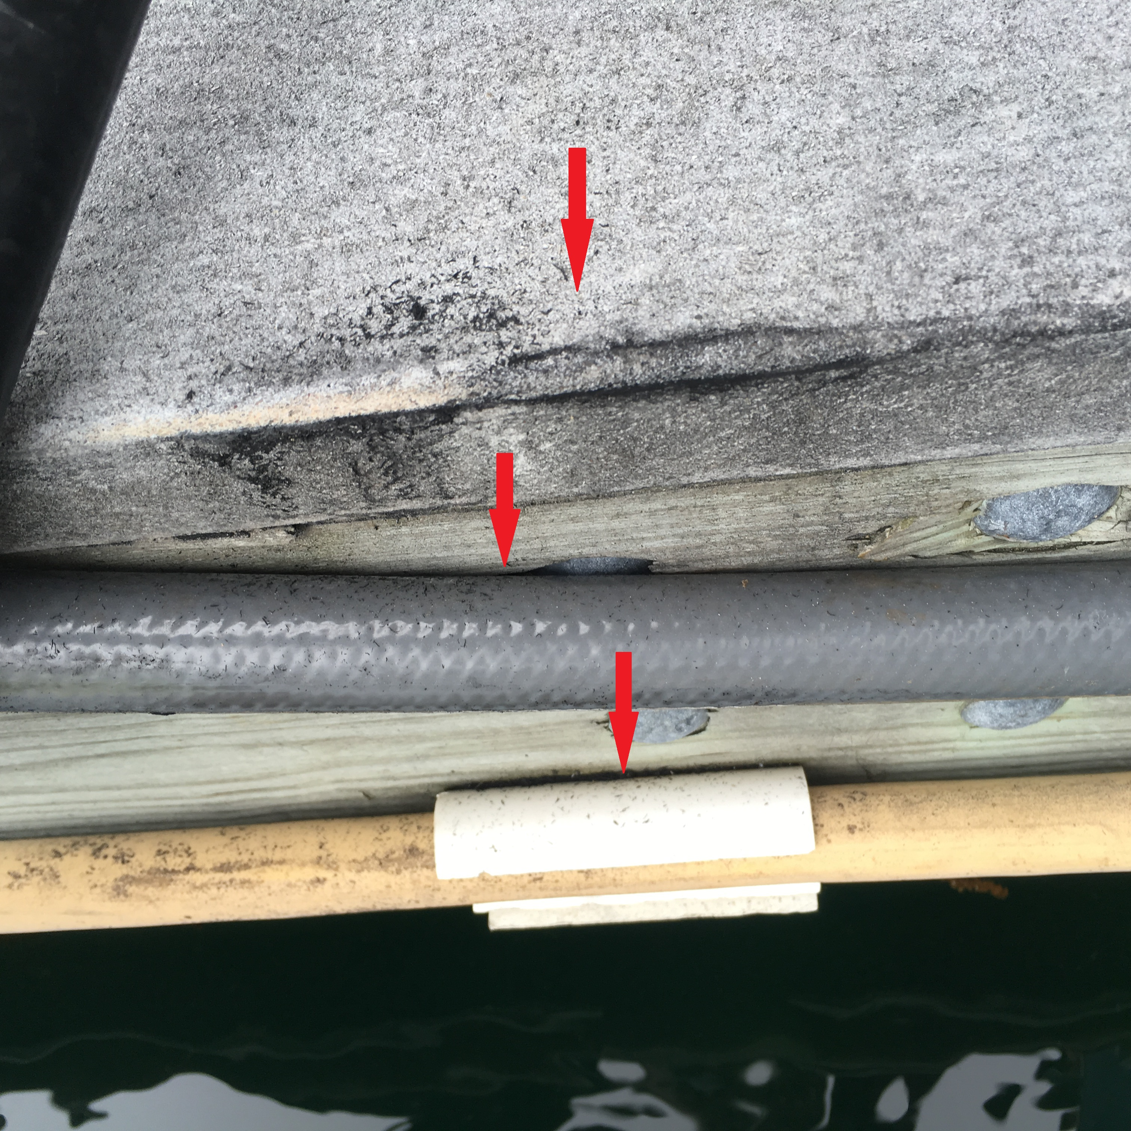

Reels: Loose grounds Loose corroded bolts with no lock washers/lock nuts
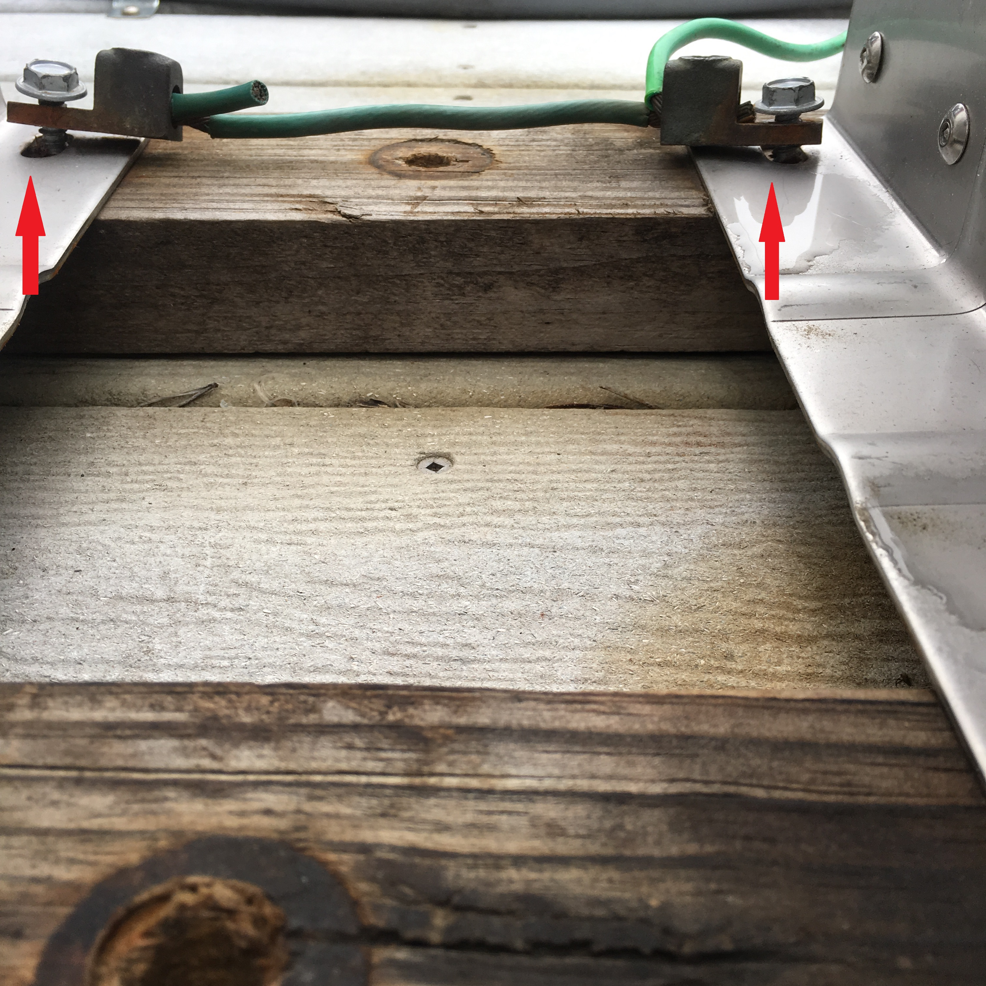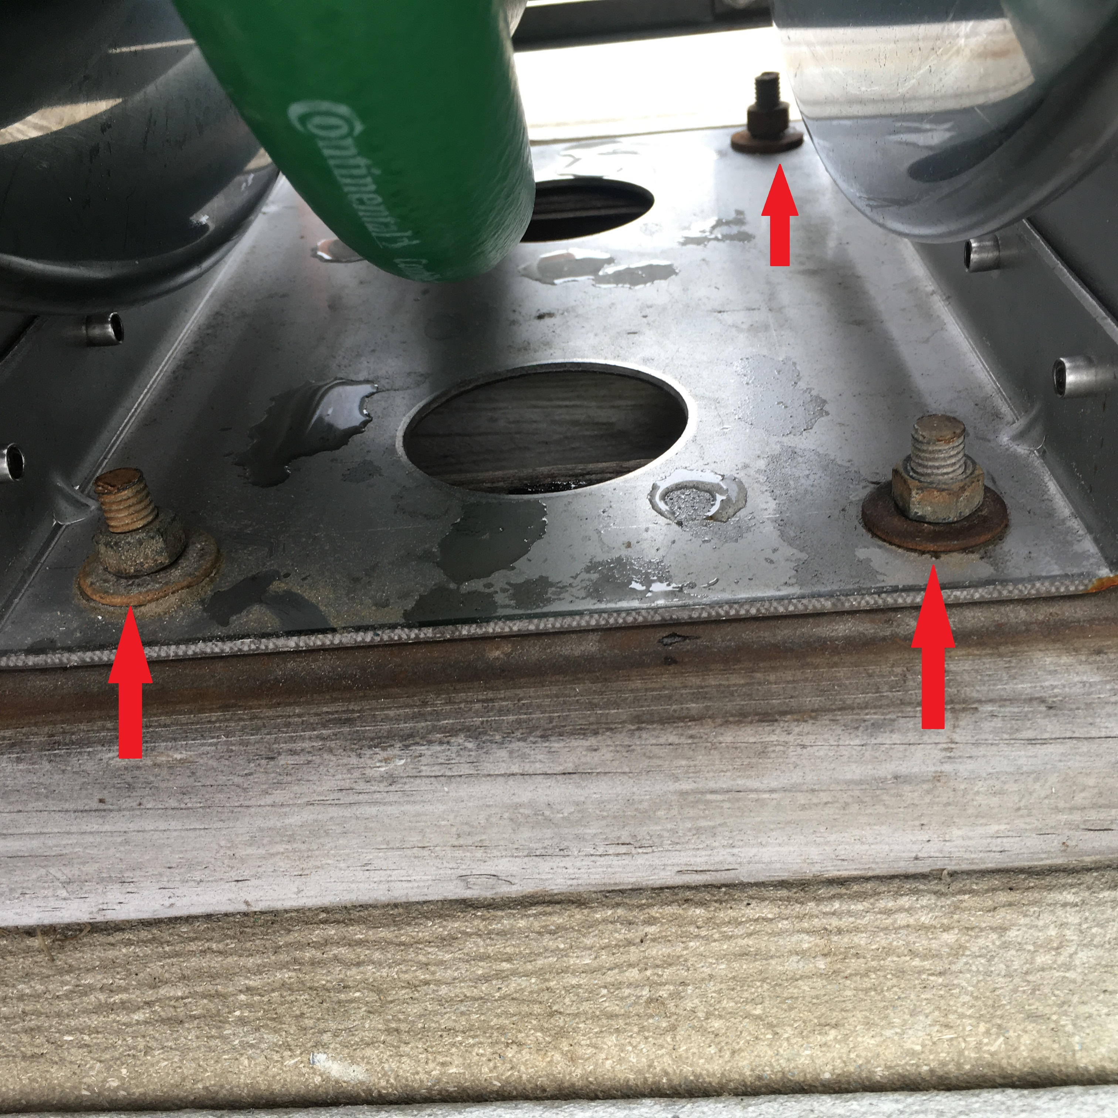

Non stainless steel screw will rust Loose Fire Extinguisher bracket
